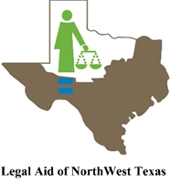

Virtual Civil Legal Clinic
Get legal help from our location to yours !

Lubbock Branch Office Service Area*

Tuesday, October 12, 2021

Tuesday, October 26, 2021

*************************************************************************************

LANDLORD/TENANT ISSUES UNEMPLOYMENT BENEFITS

FORECLOSURE PREVENTION PUBLIC BENEFITS DENIAL

MEDICARE/MEDICAID BENEFITS EXPUNCTIONS/NONDISCLOSURES

BANKRUPTCY FAMILY LAW MATTERS
*************************************************************************************
HOW TO REGISTER:

Call Christina Richey at 806 696-4610. Leave a message with your name, phone number, the best time to return your call, and a brief description of your legal issue. Someone from Legal Aid will follow up to give you an appointment time.

Space for this clinic is limited. Please contact us no later than 5 p.m. the day before clinic date to reserve your spot.

You will speak to an attorney by phone or over the internet via Zoom.

Applicants must be financial eligible to obtain free help, but all who need assistance are encouraged to apply.

*Counties Served: Lubbock, Borden, Cochran, Crosby, Dawson, Dickens, Gaines,
Garza, Hockley, Kent, Lubbock, Lynn, Terry, Yoakum

